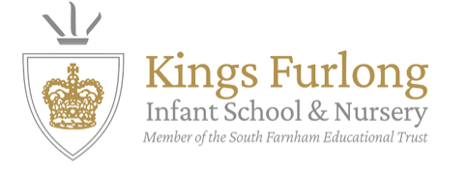
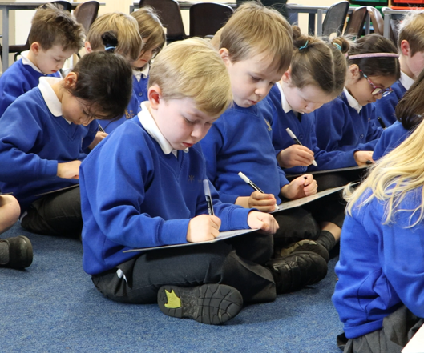

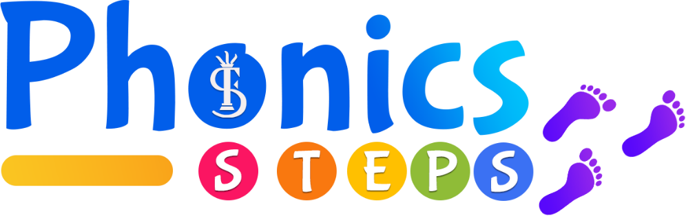

Introduction
At Kings Furlong Infant School & Nursery, every child begins their journey to becoming a confident reader and writer from day one. We start with Phonics, using a programme called Phonics Steps.
Phonics Steps represents each child’s learning journey, with small steps leading to big progress. Children move from sounds to words, phase by phase, until they reach the top of their learning staircase. Our motto, “Little steps to big results,” reflects this approach. Along the way, children meet friendly characters who share the excitement of learning to read and write, helping them to build skills, confidence and a love of learning.
Created by the South Farnham Educational Trust, Phonics Steps is based on years of successful teaching experience and expert research. Our schools consistently achieve results among the top 3% nationally in the Phonics Screening Check.
The programme follows the latest Department for Education guidance and research on how children learn best, ensuring knowledge sticks and can be applied confidently. With Phonics Steps, every child is supported to make excellent progress and take their first steps towards becoming a skilled reader.

Why teach phonics?
To become successful readers, children need to learn how to turn written words into sounds and understand what those sounds mean. This is why learning letter-sound relationships is so important. In English, each letter represents a sound, and changing the order of letters can completely change a word’s meaning. For example, if we mix up the letters in dog or pat, we might end up reading god or tap instead.

Supporting your child at home
Demystifying the terminology
Phonics teaching comes with lots of new words and phrases. The children learn this vocabulary from the very start of their journey, so they quickly become confident using it—and you may even hear them use it at home!
To support children’s progress, it really helps if everyone working with them—teachers, parents and carers—uses the same language. Below is a glossary to explain the key phonics terms.

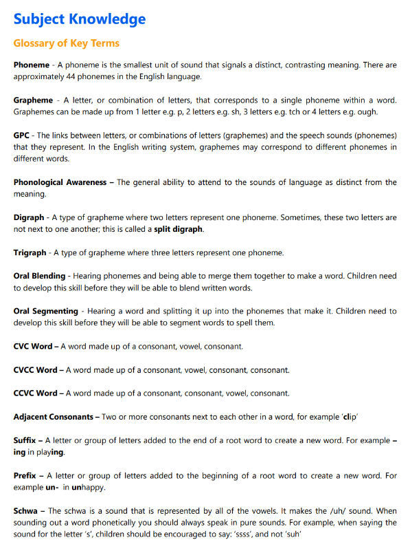

The Virtual Characters:
You may hear your child talking about their new ‘phonics friends’ at home. These friendly characters guide children through each phase of their learning journey, walking alongside them just as many children have done before.
Each character’s name has been specially chosen to match the phonics patterns taught at that stage. For example, Figgy, the very first phonics friend, has a name that uses alliteration and two syllables—important features of Phase 1. As children move through the programme, they meet new friends whose names can be sounded out using the skills and patterns they are learning. By the end, children will be able to decode every character’s name, practising the pure sounds they’ve been taught along the way.
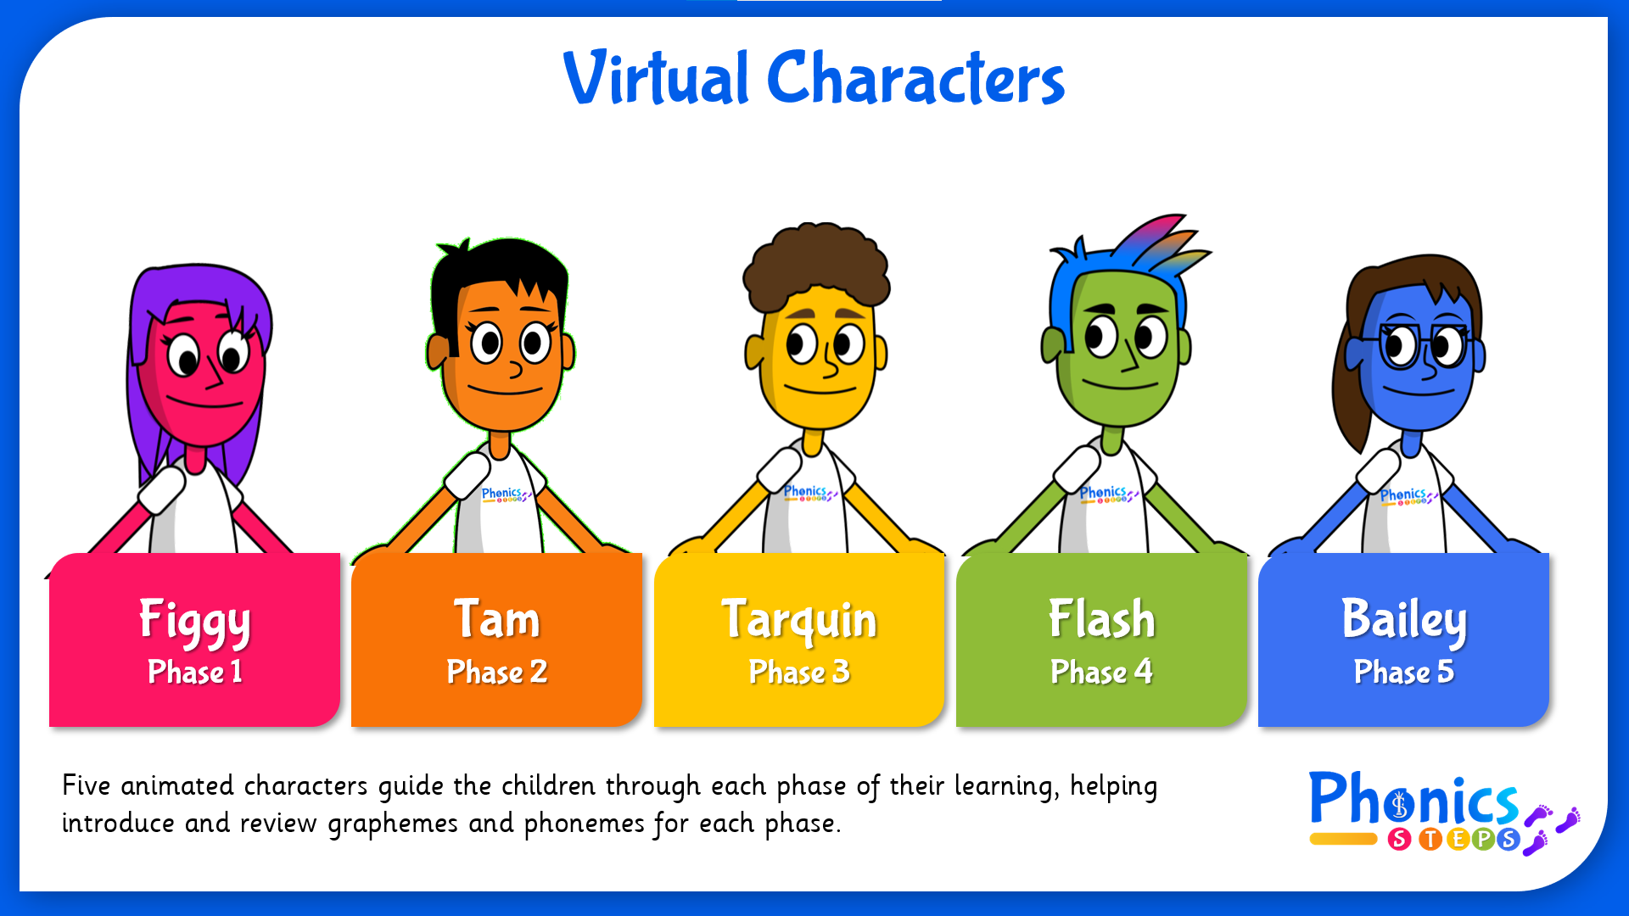

Phonics Steps Parent Portal
You can access the Phonics Steps Parent Portal using the details below. The portal is full of resources to help you support your child’s phonics and reading at home. These include:
- Handwriting guides
- Flashcards
- Pronunciation videos
- Action demonstrations for each sound
- Recorded songs to match each sound
Because these same resources are also used in your child’s phonics lessons at school, they will already be familiar with them. This consistency helps to strengthen learning and makes practising at home even more effective.

How to access the parent portal:
- Access the website at Phonics.org.uk
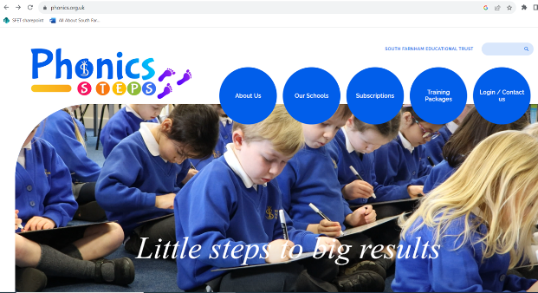

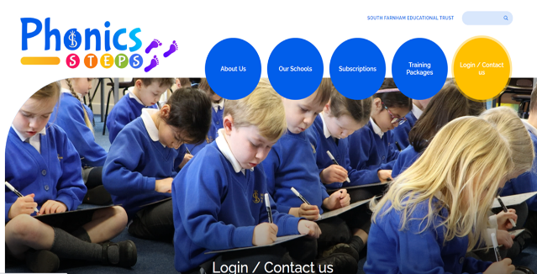
- Click ‘Login/contact us’

- Click ‘Parent login’
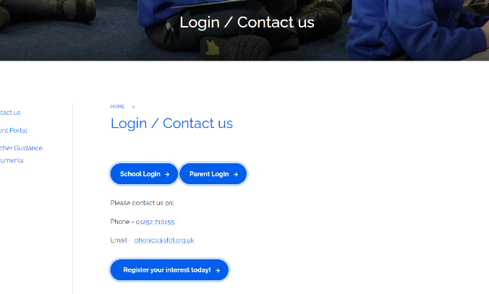

- Enter your login details:
Username: kfiparent@sfet.org.uk
Password: Phonic$2025
You will then see all available resources and be able to use these with your children.

If you have any questions please email: admin.kfis@sfet.org.uk or speak to your class teacher.

