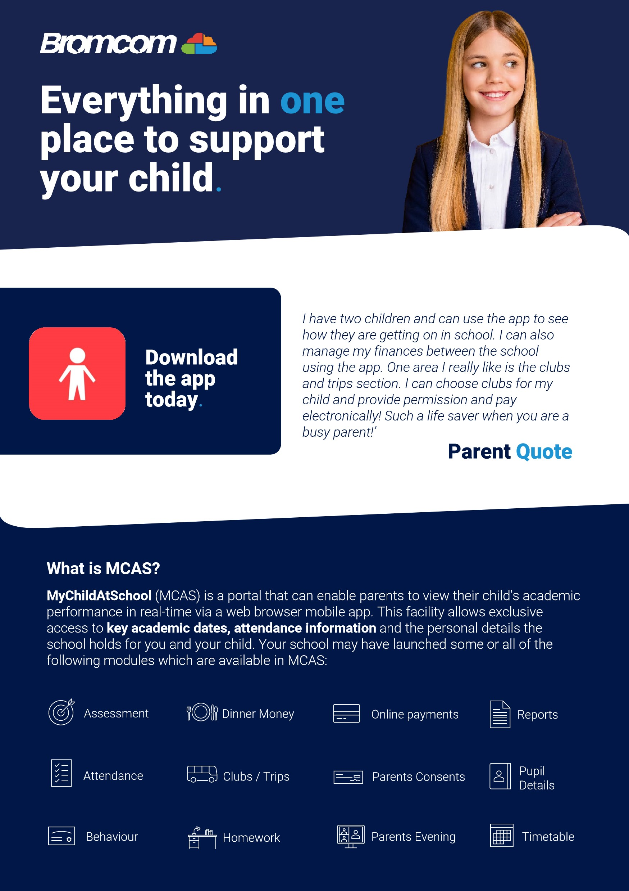
MCAS (MY C
Kings Furlong Infant School & Nursery
Upper Chestnut Drive
Basingstoke
RG21 8YJ

Friday 9th May 2025
Dear Parent/Carer

Access key information on your mobile device.
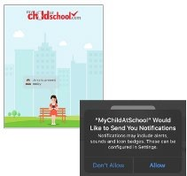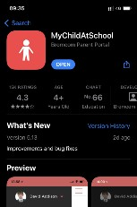
Step 1:
Download
the app.
Step 2:
Allow
notifications.
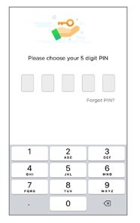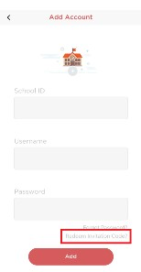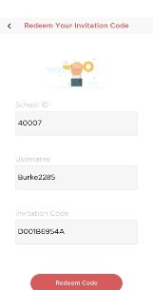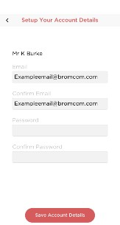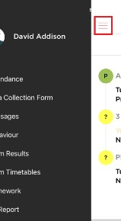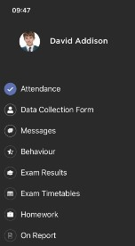
Step 3:
Choose a
memorable pin.
Step 4:
Select
Redeem Invitation
Code.
Step 5:
Add the
required information
using the email sent to
you by school and
press Redeem Code.
Step 6:
Add the
required information
and press Save
Account Details. You
will now be logged
into your account.
Step 7:
Clicking on the
3
bars provides a side
menu to navigate to
the different areas of
the parent portal.
Step 8:
The
information
displayed in the
menu is managed by
the school.
Access key information from your web browser.
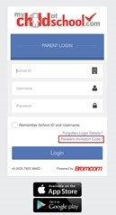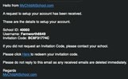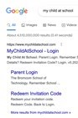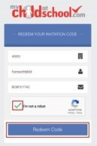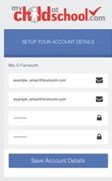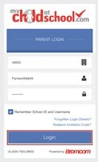
Step 1:
Search for
MyChildAtSchool
Login page.
Step 3:
Add the
required information
using the email sent
to you by school .
Step 4:
Select
Redeem Code.
Step 5:
Add the
required information
Click Save Account
Details.
Step 6:
Log into your
MyChildAtSchool
Account.
Step 2:
Select
Redeem Invitation
Code.
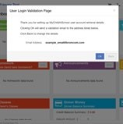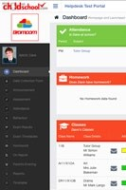
Step 7:
Login to
your email and
validate your email
address.
Step 8:
Go back to
MyChildAtSchool
and
log into your account to
complete the process.

