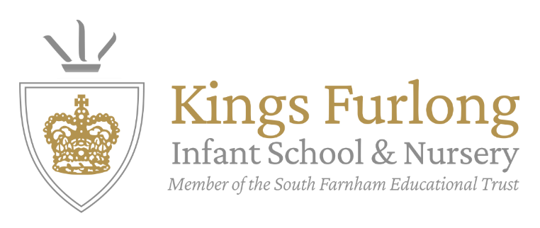

Music Development Plan summary

Overview
Detail | Information
Academic year that this summary covers | 2025-2026
Date this summary was published | September 2025
Date this summary will be reviewed | July 2026
Name of the school music lead | Lucy Irving
Name of school leadership team member with responsibility for music (if different) | Lauren Herring
Name of local music hub | Hampshire Music Service

This is a summary of how our school delivers music education to all our pupils across three areas – curriculum music, co-curricular provision and musical experiences – and what changes we are planning in future years. This information is to help pupils and parents or carers understand what our school offers and who we work with to support our pupils’ music education.

Part A: Curriculum music
This is about what we teach in lesson time, how much time is spent teaching music and any music qualifications or awards that pupils can achieve.
Our broad and balanced curriculum is informed by the Model Music Curriculum and research outline in ‘The power of music to change lives: a national plan for music education’.
Children at Kings Furlong Infants receive one hour dedicated music lesson per week. The progression of skills and knowledge overview clearly outlines how the children will engage with the inter-related dimension of music: texture, structure, timbre, tempo, dynamics, pitch, rhythm, pulse, and our spiral curriculum enables the children to have comprehensive music vocabulary by the time they finish their infant music education. The document also maps the key knowledge and skills to be taught within each year group to enable them to progress to this level.
We break our curriculum into 5 key aspects of music, which are commonly recognised vehicles for developing children’s musical understanding in a holistic and interconnected way. These are: listening and appraising, singing, playing, improvising, composing. In our curriculum, these activities serve as the structure for every lesson – enabling children to practise in small steps and acquire knowledge and skills carefully over time.
We follow the Charanga Music School scheme to meet the expectations of the Model Music Curriculum and exceed the National Curriculum. The scheme allows children to practise each of the strands of music within each lesson and has a clear progression of skills within each unit. The planning includes clear differentiated tasks with both additional support and extension tasks (such as the use of sheet music and a variety of complexity in the melodies and rhythms). By following a scheme, we can ensure consistency between classes and parity across year groups.
In response to the 2011 review of music, we introduced Whole-Class Ensemble Teaching (WCET) into our curriculum. Each year group at Kings Furlong Infants participates in WCET, introducing them to or deepening their skills in a specific instrument. These are a key part of the school’s curricular music offer and not a bolt-on activity - as advised by the 2022 national plan for music education.
Each year group also studies a specialist History of Music Unit, giving children an opportunity to acquire a deep understanding of a particular aspect of music history. This includes explicit teaching of various music theory concepts (e.g. recording notation), which can be applied within practical teaching units. The History of Music Unit also emphasises the importance of music history and understanding the rich cultural heritage of music.
Our curriculum also features a half term Ensemble Singing Performance Unit, which contextualises their learning and enables children to experience the wonder and joy of live performance. The children also develop stamina to sing and dance simultaneously and the unit leads up to every child performing in our Christmas production.

Part B: Co-curricular music
This is about opportunities for pupils to sing and play music, outside of lesson time, including choirs, ensembles and bands, and how pupils can make progress in music beyond the core curriculum.
Music is an integral part of life at Kings Furlong Infant School and children are encouraged to participate in extra-curricular activities. Our aim is to increase self-confidence, creativity and a sense of achievement, which we understand cannot just be contained to a single music lesson once a week. We offer a variety of different clubs and experiences throughout the year and our ethos ensures inclusivity into our choirs, which we offer for free.
We offer a Kings Furlong Infant School Choir, open to any child to join, with multiple performance opportunities throughout the year, covering a variety of genres and venues.
Our 2025-2026 academic year sees the introduction of using the ‘Create Music’ initiative to offer an opportunity for our children to try their hand at the Ukulele, giving children the chance to learn an instrument – in a group setting – with new songs. Led by an experienced guitarist and Ukulele player, the children will learn key ensemble skills.
Our curriculum team regularly meet to assess the success of the clubs running at the school and will choose our termly offerings based on the need of the children. Our offering is constantly changing and growing and will be adapted throughout the year.

Part C: Musical experiences
This is about all the other musical events and opportunities that we organise, such as singing in assembly, concerts and shows, and trips to professional concerts.
On top of the timetabled music lesson, the children attend a 20 minute singing assembly each week; they are taught a new song during the assembly and then sing it throughout the week at all other assemblies they attend.
There are copious opportunities for children to experience Music and Performing Arts outside of the classroom.
Throughout their time at Kings Furlong Infants, children are frequently given opportunities to work with, and perform to, the local community – reflecting our commitment to broadening children’s experiences beyond the school. This community engagement is also a reflection of the value that Kings Furlong places on enriching and support our wider community.
- At Christmas, we bring together a group of children to perform Christmas Carols to local care homes near us. The children can experience the joy music brings and how community spirit is an integral part of music.

In the future
This is about what the school is planning for subsequent years.
The Music Curriculum team are continually looking for ways to exceed and our action plans are bold and ambitious.
We currently uphold and value the strengths we have within the 7 key features of enriched curriculum and have created an action plan that is reflect of this.
Our targets for 2025-2026 are to:
- Review WCET and History of Music units to diversity artists.
- To continuous implement a dynamic CPD programme.
- To implement new assessment procedures within Music to ensure judgements of the highest accuracy.
- To enhance opportunities to involve music within the local community
- Offer more opportunities for co-curricular music within the school
We will continue to keep up-to-date with any research or responses to the national plan for music education and the model music curriculum and implement within our curriculum as necessary.

